Toura Travel Therapy @thabothetourist
&
City Sightseeing SA Redbus
Presents

Redbus Art Experience
“Hop-On Curious, Hop-Off Inspired”

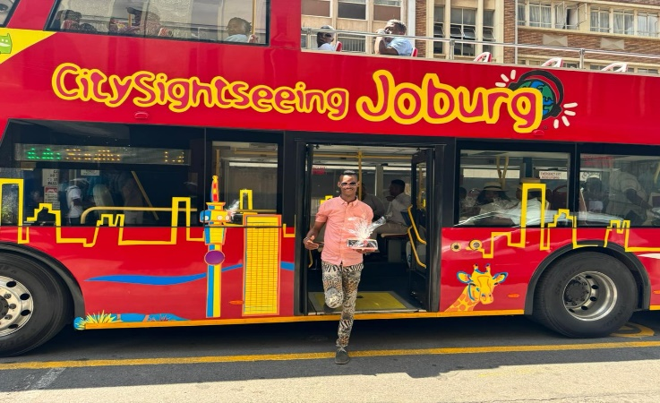

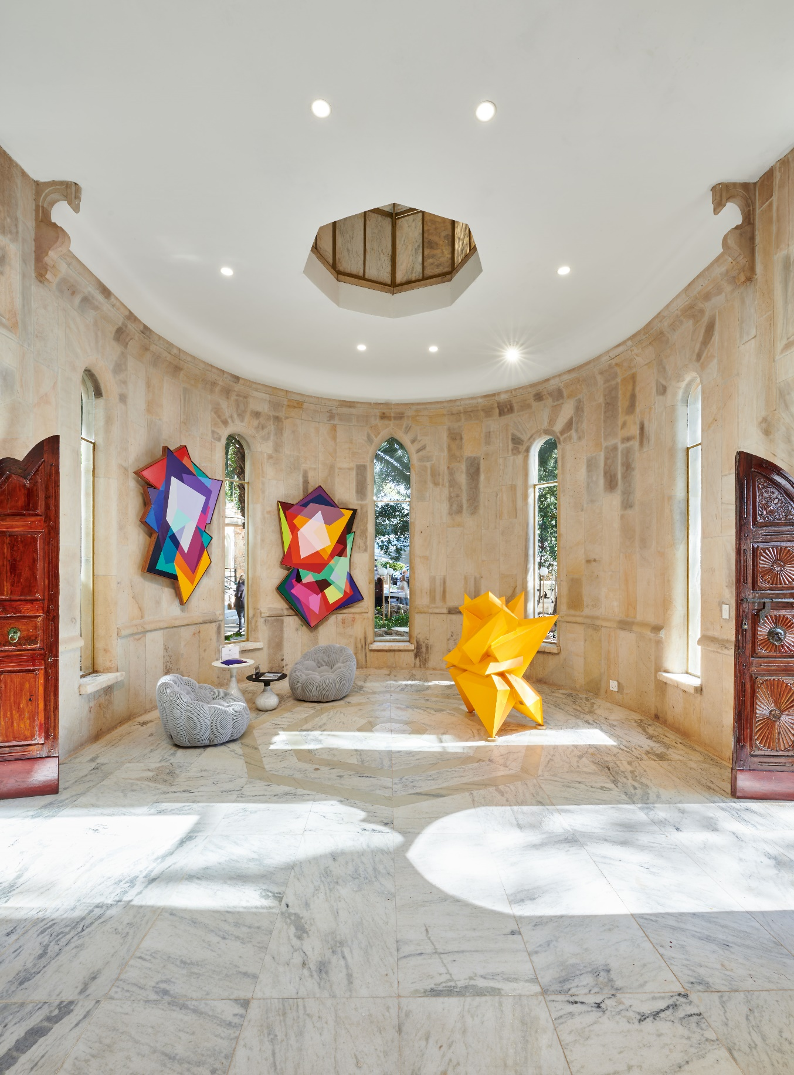

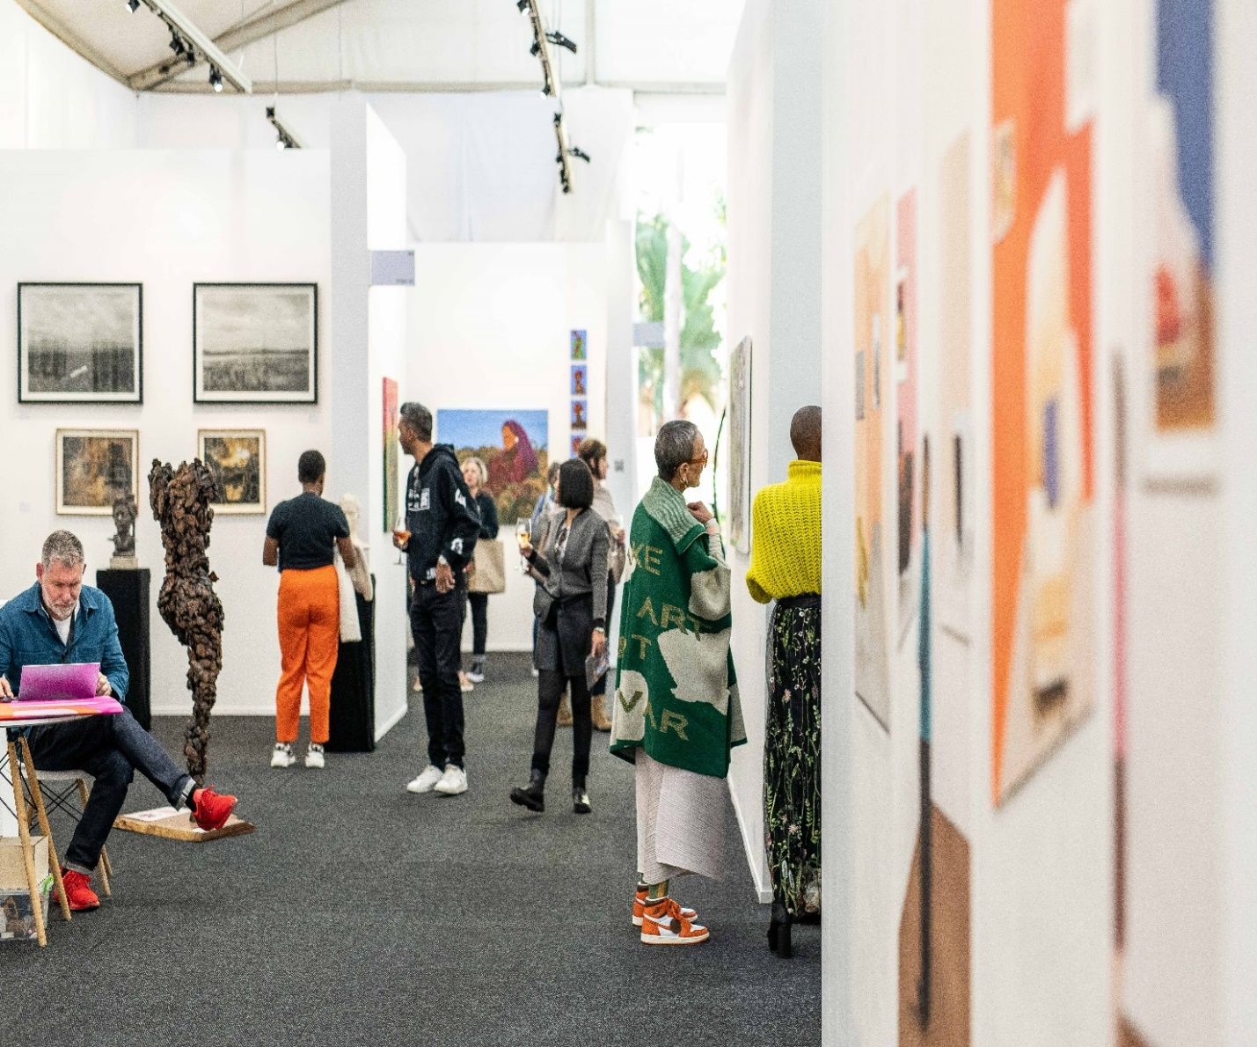

Step into another world of enchantment, networking and adventure by hopping on Johannesburg’s renowned art studios and a visit to the iconic Shepstone Gardens for an enriching indoor-outdoor art experience with the one and only art-tourism connoisseur, Thabo the Tourist. Join us as we roll a red-carpet for a unique Redbus Art Studio Hopping and Art Fair experience through the multi-cultural districts, bustling business node, and captivating tourist attractions of South Africa.
Immerse yourself in the rich tapestry of Johannesburg’s northern suburbs and CBD, including Rosebank, Troyville and Houghton Estate. Your art enthusiast tour curator, Thabo the Tourist, will lead you through this artistic journey. Experience the healing power of art in a unique, memorable and fun way. Step out of your comfort zone and embark on a positive journey tailored to your interests.

Interacts with curators, gallerists, locals, and distinguished artists along the way. Immerse yourself in the electrifying economic movement and lifestyle of Johannesburg’ s north.

Prepare to be amazed by a stunning collection of sculptures, photographic exhibitions, and contemporary African fine art exhibitions featuring African artists curated by Africans, right here in Africa. Feel free to make art purchases, during and after the enriching experience.

Our adventure begins at the Redbus pick-up stop in Rosebank at 10am, leading us to Joburg central for studio hopping, we’ll visit the renowned art studios like Creative uprising Transwerke, Rand Club and Bag Factory Artists’ Studios, before heading down to Shepstone Gardens to visit the RMB Latitudes Art Fair.

We’ll conclude our tour by hopping-off to our meeting points for departure or departing from the art fair.

Join us for a studio hopping and art fair experience like no other. Let art and culture guide your way with Thabo the Tourist and the iconic Redbus!

Details

Date: 25 May 2024.
Schedules: Leave first stop at 10am.
Tour type: Open-roof tour bus.
Duration: 7-8 hours.
Included: Engaging competitions, Lucky draws etc.
Landmarks: Oxford Road.
Constitutional Hill.
Braamfontein.
Joburg CBD.
Mandela Bridge.
Newtown Precinct.
Presidential Suburb (Houghton Estate).
Shepstone Gardens.
And more.
😊

